**IAB207-assignment3-group-66**

Erin He n10167391  
Xinying Ren n10068350  
Weitong Ma n10273891  
Xinyun Wu n10113134

**screenshots of all the pages described in the test script**

1. The landing page of the application will be accessed. The ‘search-by-category’ feature that allows a user to view items by category will be tested.

1.1 landing page





search function

1.2 

2. The details of one of the items on the landing page will be assessed. The user should be able to the status of the item. The user can either ‘bid on item’ or ‘add to watchlist’. The user who listed the item will be able to ‘close the auction’ and ‘view all bids’

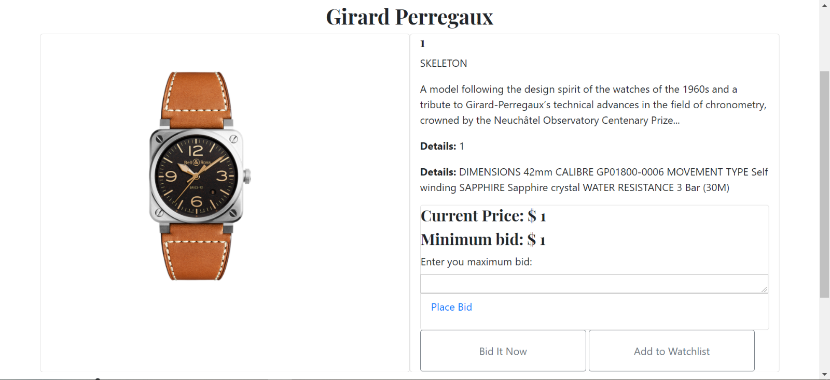

The user can see all bid

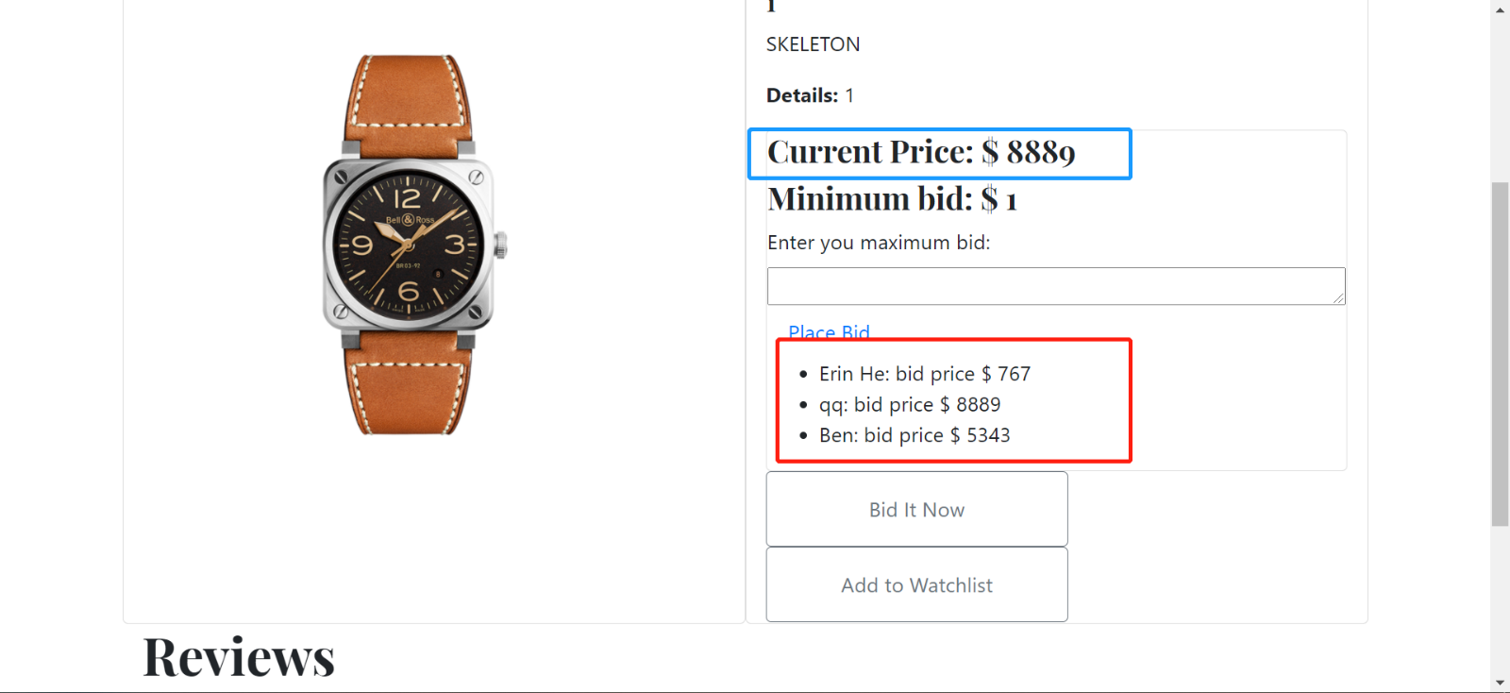

The user is able to close the bid.

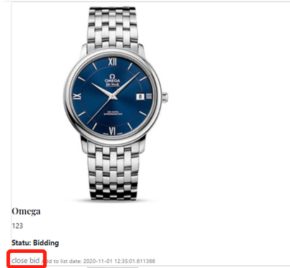

3. On trying to create item, the user should be prompted to a login page.



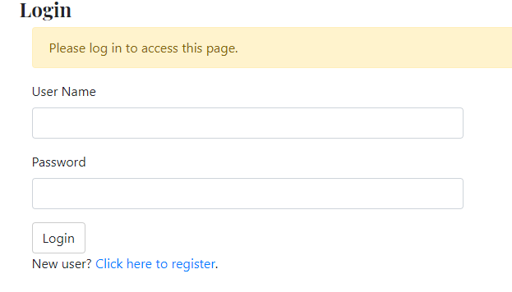3.2.

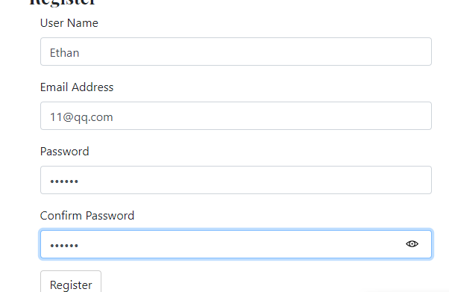4. Three new users will be registered, and details of the registration page will be tested.

4.1.register：

4.2. three users are able to register.





5. One user will login to the application.



6. The user will create two items. The item creation will be tested

Create：

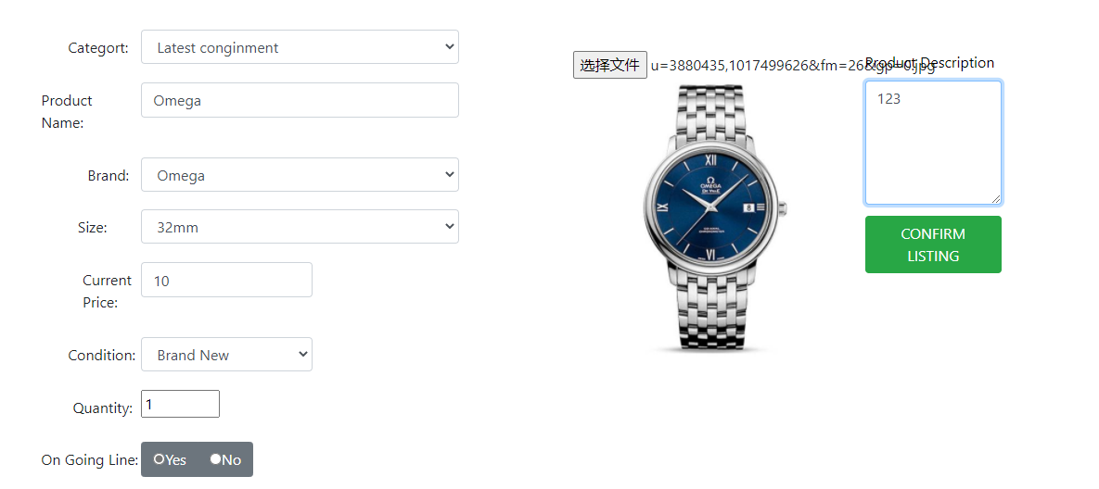

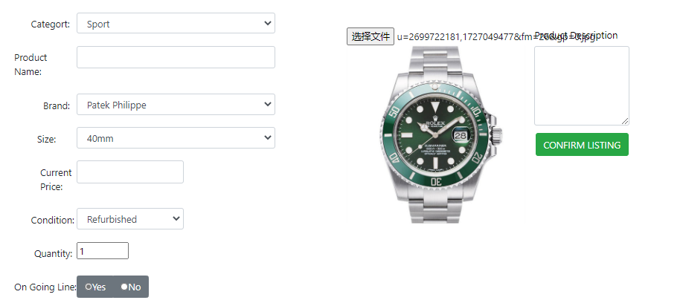

Two items are able to be created.





The watchlist is able to see “add to watchlist” items. And delete item from watchlist.

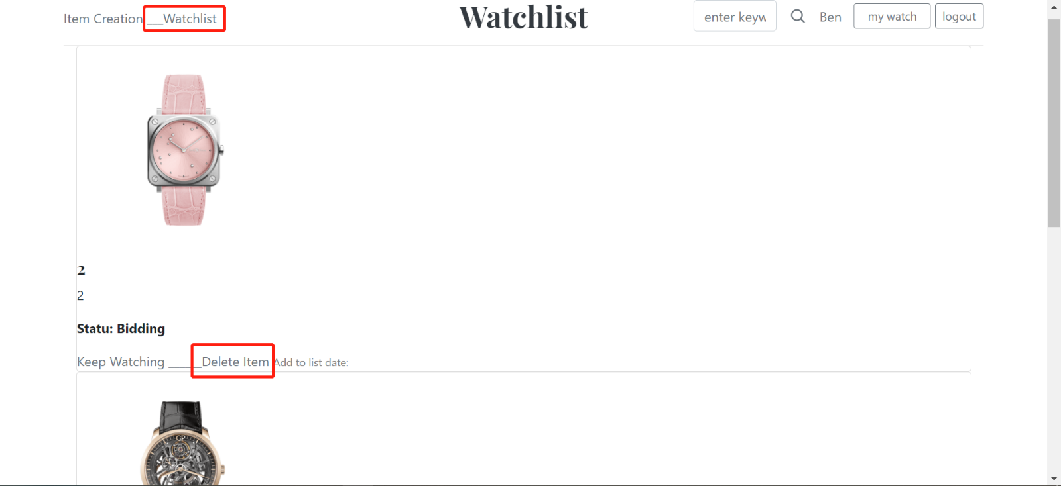

7. The user will logout of the application. Logout functionality will be tested.

7.1

7.2

8. The ‘bid on an item listing’ functionality will be tested. The user should be taken to the login page if a user is not logged-in.

When the user wants to see details: jump to the login screen

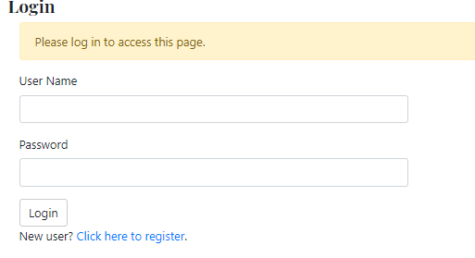

9. The user will login and enter bid amount that is lower than the starting bid. The user will be prompted with an appropriate error message. The user will enter a valid bid amount.

When the bid is less than min bid or current bid:

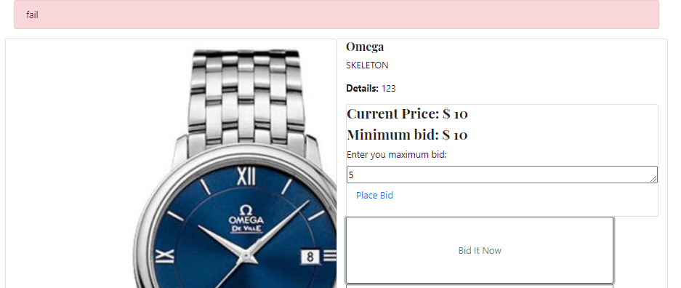

10. Another user will bid with a higher bid amount and add to Watchlist

Bid:

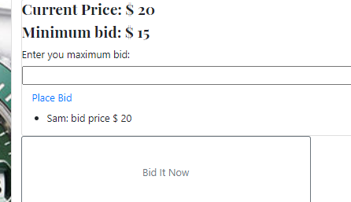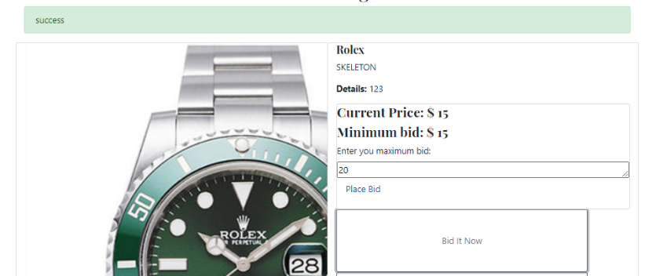



11. The user who has listed the item will close the auction



12. Relevant updates to the status of the auction will be checked.

Update bids:



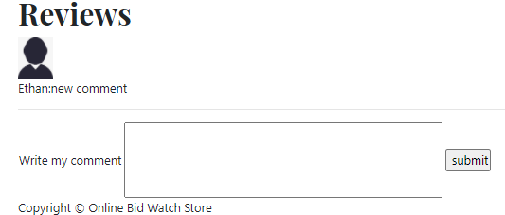Comments:

**The Heroku URL for your web application.**

GitHub link: <https://github.com/ErinHe1114/IAB207-assignment3-group-66.git>

Heroku link: <https://iab207-assignment3-group-66.herokuapp.com/>

Problem：

When I run the site locally using VS, the project can be successfully created



But when I tried to use Heroku to run the site and create it, the system told me that I needed to upload an image (after I had uploaded the image).

